[GVK BIO](http://www.gvkbio.com/)

Requirement Specification Document

Version: 1.0

To

**Surface Water Profiling automation**

GVK Biosciences Private Limited

Informatics Division

Plot No: 79, Nacharam,

IDA Mallapur, Hyderabad – 500076, India.

Tel: +91 40 6736 6200 / 6736 6300

Fax: +91 40 67366444

Document Revision History

|  |  |  |  |
| --- | --- | --- | --- |
| **Ver #** | **Date** | **Author** | **Comments** |
| 1.0 | Jan 16, 2014 | GVKBIO | Initial Draft |

**Table of Contents**

1 Introduction 4

1.1 Overview 4

1.2 Purpose 4

1.3 Intended audience 4

2 Business Process Understanding 4

2.1 System Functional Overview 4

2.1.1 High Level System Context 4

2.1.2 Technology Overview 5

2.1.3 System interfaces Overview 5

2.1.4 Data Model 5

3 Business Requirements 5

3.1 Application Scope and Boundary 5

3.2 Users of the Application 6

3.3 Data Requirement for Process 6

4 Application Flow 6

4.1 Login Screen 6

4.2 Surface water profiling 7

4.2.1 Input data and profiling 7

5 System Requirements 7

5.1 Application Architecture 7

5.2 Architecture Requirements 7

5.2.1 Miscellaneous system requirements 8

5.2.2 Pending decisions and Risks 8

6 Data Migration Requirements 8

7 Backup & Data Recovery Requirements 8

8 Special User Requirements 8

8.1 User Training 8

8.2 User Manual & Help 8

9 Risk 8

10 Document reference 8

11 Open Issues 8

12 Review and Sign Off 8

REQUIREMENTS SPECIFICATIONS

# Introduction

## Overview

*Scientific team will generate reports from modeling software. Automation is required to generate graphs for each report and create a surface water profile.*

## Purpose

*Generate surface water profiles from the reports generated by the modeling software.*

## Intended audience

*The objective of this tool to reduce manual effort and improve quality & correctness of data.*

# Business Process Understanding

## System Functional Overview

* *Read .cwa, .cs1 files generated from modeling software*
* *Import the data of each file and generate graph*
* *Combine all graphs into word document to create a profile*

### High Level System Context

* Read .cwa or .cs1 text file in selected folder
* Calculate Max value in a day for all days
* Generate graph on Max value for 365 days
* Export each graph to word document

**Figure 1**

***Application Work flow***

***Comparing input files (Input Summary data sheet vs. Software generated input parameters data)***



**Figure 2**

### Technology Overview

Application runs on individual client machine

### System interfaces Overview

* *Select a folder which has .cwa, .cs1 and .sum files*
* *Read value for Crop*
* *Generate excel file for each .cwa and .cs1 input file*
* *Export graphs of each excel file into one common word document*

### Data Model

ER data model:

NA

# Business Requirements

* *Automation required to generate Surface water profiling report*

## Application Scope and Boundary

* *Read .cwa and .cs1 file from selected folder*
* *Generate excel report for each .cwa and .cs1 file*
* *Export all graphs to a word document*

## Users of the Application

Below are the users of Application:

| **Role** | **Responsibilities** |
| --- | --- |
| Scientific Team | * Users of surface water profiling |

## Data Requirement for Process

* Input data files

# Application Flow

## Login Screen

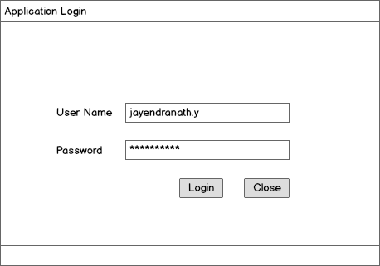

**Figure 4**

User authentication is to validate the user is authorized person to use the application. It should be performed by using the Active Directory login credentials.

* User enters Active Directory *USERNAME*, *PASSWORD*.
* Then click on OK button.
* LDAP authentication is processed,
* On successful login, it takes to respective form.
* On login failure, it displays error message as “Invalid Username/Password”.

## Surface water profiling

### Input data and profiling

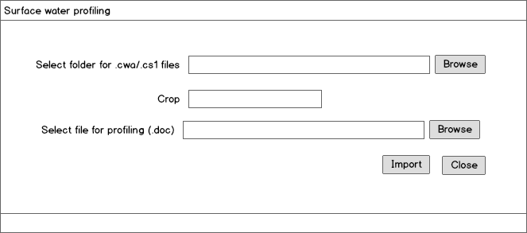

**Figure 5**

Above screen is to read input files (.cwa and .cs1) file and generate profiling document

* **Select folder for .cwa/.cs1 files:** Select the folder location where .cwa and .cs1 files are stored
* **Crop:** This a property value which will be provided by the user and this value is add in profiling
* **Select file for profiling (.doc):** Select a document name or folder path to save all the graphs exported from excel file.

Application should read each .cwa or .cs1 file in select folder and Follow the steps defined in below attached document.



# System Requirements

Informatics will use the current infrastructure for Application development

## Application Architecture

NA

## Architecture Requirements

* *Application will be a windows based application developed using Microsoft .Net framework 4.0.*

### Miscellaneous system requirements

* **Operating System**: Windows 7.0, MS Office 2007

### Pending decisions and Risks

NA

# Data Migration Requirements

NA

# Backup & Data Recovery Requirements

*NA*

# Special User Requirements

## User Training

Training on application usage

## User Manual & Help

NA

# Risk

* Software generated input and output in specific format

# Document reference

* FFA_WC_00_S4_10M NSZ & VFS using FOCUS L&M.rar
* FFA_D1_Ditch_10m.xlsx
* Profile.docx

# Open Issues

# Review and Sign Off